3.4 Quadratic Inequalities

Solving f(x) > 0 means finding x values for which f(x) is above the x-axis.
Solving f(x) < 0 means finding x values for which f(x) is below the x-axis.

Example: Solve the inequality graphically

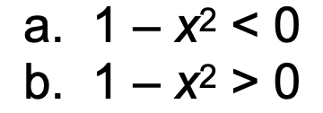

a) (-1, 1)
b) (-infinity, -1) U (1, infinity)

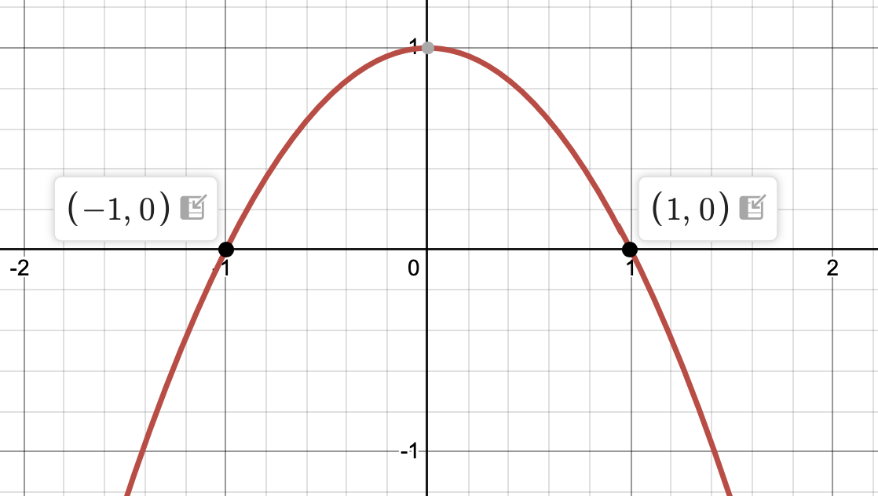

Example: Solve the inequality graphically
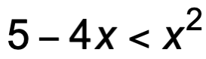

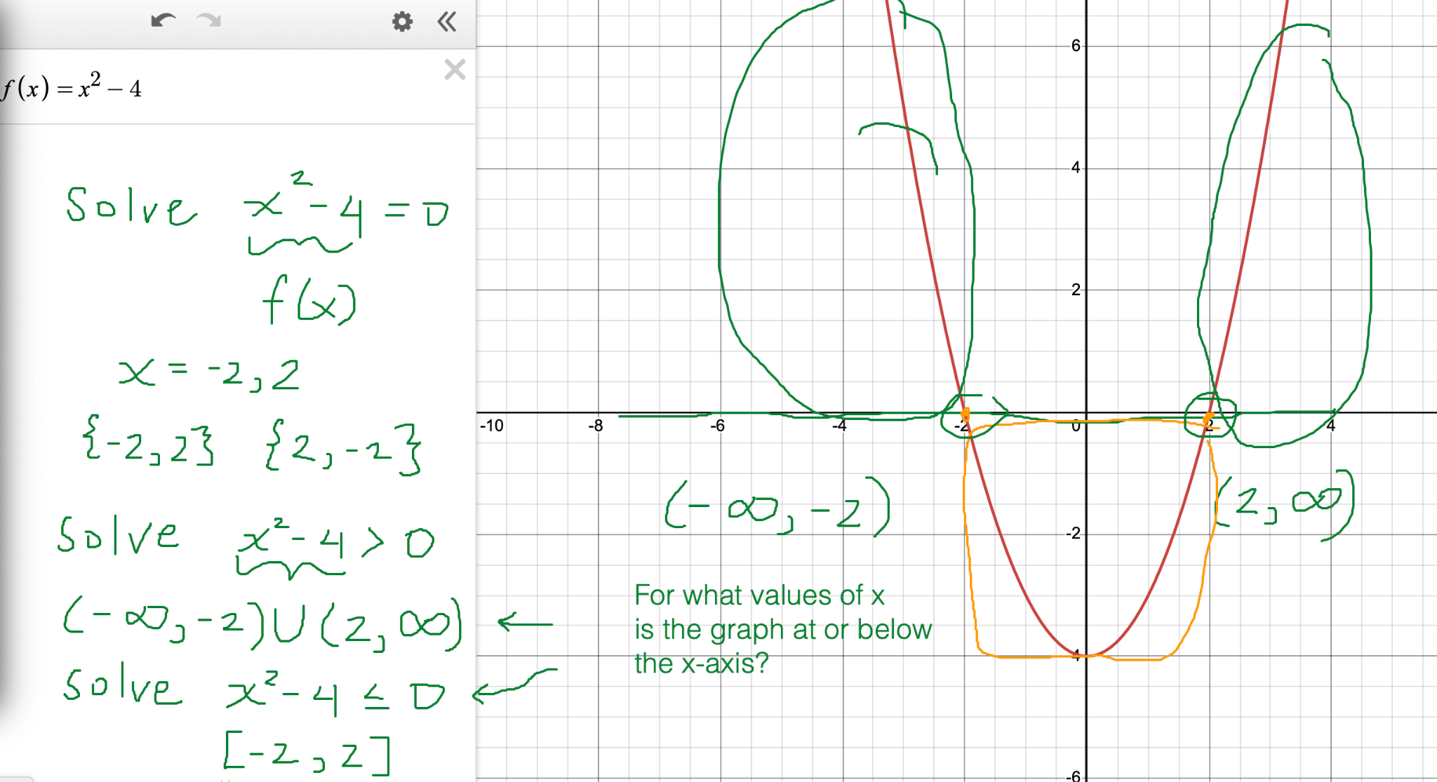

How to solve quadratic inequalities algebraically
